JSY-MK-323 Three-phase intelligent power monitor

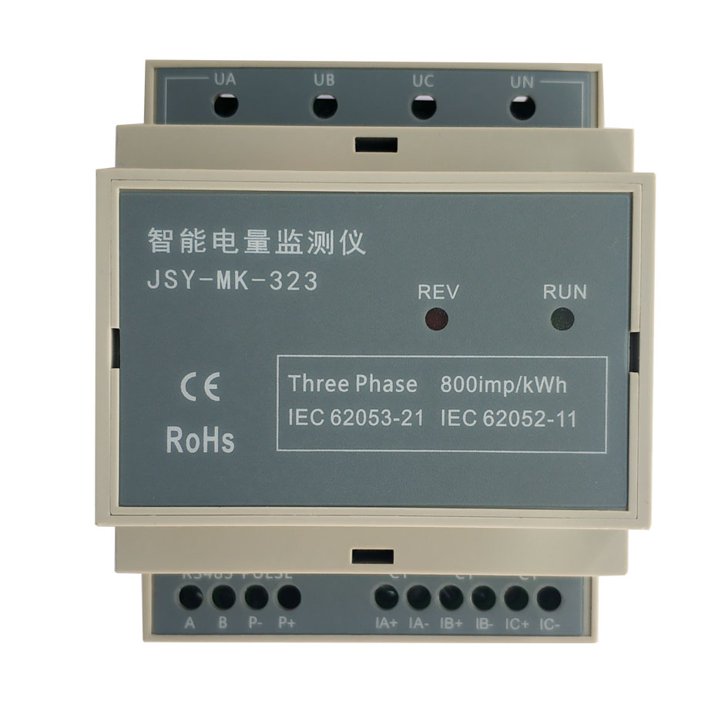
Product description

1.1 Introduction
1.2 Features
1.3 Technical parameter
- Application
2.1 Shape and installation
2.2 Terminal definition
2.3 Typical wiring
2.4 Application note
- ModbusRegister
- MODBUS Communication protocol
- Precautions

一、Product description
- Introduction
The JSY-MK-323 three-phase intelligent power monitor is a three-phase intelligent power monitor with completely independent intellectual property rights developed by our company using microelectronics technology, special large-scale integrated circuits, digital sampling processing technology and SMT technology and other advanced technologies. instrument. The technical performance of the monitor fully meets the relevant technical requirements of the class 1 three-phase active energy meter in the IEC 62053-21 national standard, and can directly and accurately measure the voltage, current, power, and power in the three-phase AC power grid with a rated frequency of 50HZ or 60HZ Electrical parameters such as factor, power and total amount. The tester has a built-in RS485 communication interface and MODBUS-RTU communication protocol to facilitate connection with various AMR systems. It has the characteristics of good reliability, small size, light weight, beautiful appearance, and convenient installation.
JSY-MK-323 three-phase intelligent power monitor can be widely used in energy-saving transformation, electric power, communication, railway, transportation
, Environmental protection, petrochemical, steel and other industries, used to monitor the current and power consumption of AC equipment.
- Features
- Collect three-phase alternating current parameters, including multiple electrical parameters such as voltage, current, power, energy, etc., with full information;
- Adopt dedicated measurement chip, effective value measurement method, high measurement accuracy
- With 1 RS-485 communication interface
- The communication protocol adopts standard Modbus-RTU, which has good compatibility and convenient programming;
- RS-485 communication interface with ESD protection circuit
- Wide working voltage AC80～240V
- Using industrial-grade chips, built-in watchdog, and has perfect lightning protection and anti-interference measures to ensure reliability
- High isolation voltage, withstand voltage up to AC:2000V
- Optional single-turn through-core transformers or split-type transformers of different specifications, convenient and easy to use
(Note: Opening-closing current transformers are mainly used in the transformation of industrial mid-city grids, power transmission systems, and rural projects.
Convenient installation, no need to disassemble the bus once, and it can also be operated with electricity, and does not affect the normal power consumption of customers, and is modified for users
The project saves a lot of manpower, material resources, and financial resources, and improves the efficiency of transformation. This series of open-close current transformers can be used with relays
It is used in conjunction with the protection, measurement and ammeter measurement devices.)

- Technical parameter
- Three-phase AC input
  - Voltage range: 100V, 220V, 380V, etc. Optional;
  - Current range: 5A, 20A, 50A, 100A, 200A, etc. optional; external open-ended current transformer models are optional;
  - Signal processing: using dedicated measurement chip, 24-bit AD sampling C;
  - Overload capacity: 1.2 times the range can be sustained; instantaneous (<200mS) current 5 times, voltage 2 times the range is not damaged;
  - Input impedance: voltage channel＞1 kΩ／V; current channel ≤100mΩ;
- Communication Interface
  - Interface type: Provide 1 RS-485 interface;
  - Communication protocol: MODBUS-RTU protocol;
  - Data format: software settable, "n,8,1", "e,8,1", "o,8,1", "n,8,2";
  - Communication rate: RS-485 communication interface baud rate can be set to 1200, 2400, 4800, 9600Bps; the factory default baud rate is 9600bps, data format "n,8,1"；
  - Communication data;
Multiple electrical parameters such as voltage, current, power, energy, etc., see Mdobus data register list
- Measurement accuracy
Voltage, current, power: ±1.0%; active power level 1
Isolation
DO/RS-485 interface, isolated from AC power supply, voltage input, current input; isolation withstand voltage 2000VDC；
- Power supply
  - Optional 100V, 220V, 380V, voltage line 100V～380V
When AC220V power supply, the peak voltage shall not exceed 265V; typical power consumption: ≤2W;
- Working environment
  - Working temperature: -20～+60℃; Storage temperature: -40～+85℃;
  - Relative humidity: 5～95%, no condensation (at 40℃);
  - Altitude: 0～3000 meters;
  - Environment: no explosion, corrosive gas and conductive dust, no significant shaking, vibration and impact place;
- Temperature drift: ≤100ppm/℃;
- Installation method: 4P rail installation;
- Module size: 70*90*57mm

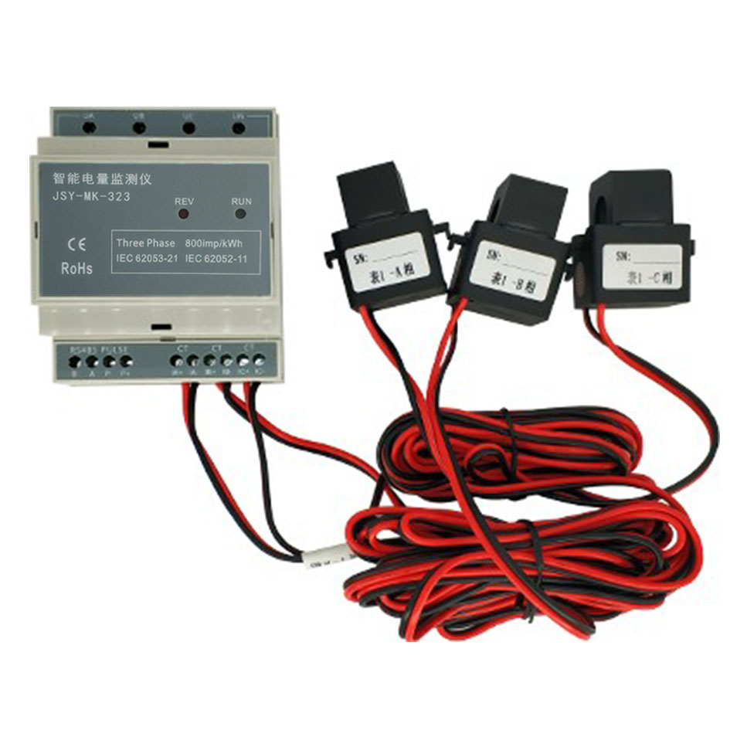
二、Application
- Shape

图 2.1
Installation: Use 4P guide rail to install, after fixing the guide rail, just snap the module into the guide rail;
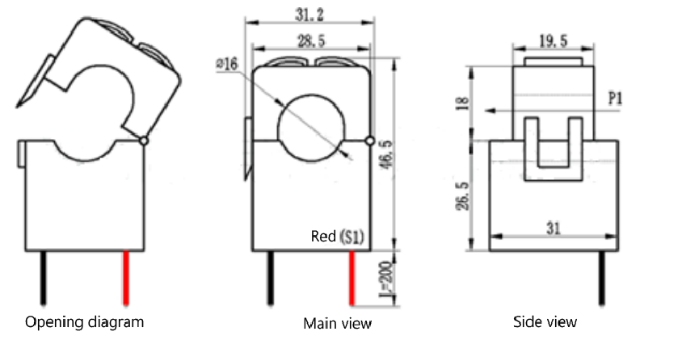

100A Dimensional drawing of open-type current transformer

- Terminal definition
Terminal | Definition | Illustrate | Terminal | Definition | Illustrate
 | UA | Phase A voltage input |  | A | RS485 positive
 | UB | Phase B voltage input |  | B | RS485 negative
 | UC | C-phase voltage input
 | UN | Neutral input |  | P+ | Pulse output signal positive
 |  |  |  | P- | Pulse output signal negative
 | IA+ | A phase current transformer+
 | IA- | A phase current transformer-
 | IB+ | Phase B current transformer+
 | IB- | B-phase current transformer-
 | IC+ | C-phase current transformer+
 | IC- | C-phase current transformer-

- Application note
Please refer to the above diagram for correct wiring according to product specifications and models. Be sure to disconnect all signal sources before wiring to avoid danger and damage to the equipment. After checking that the wiring is correct, turn on the power to test.
After the power is turned on, the "power" operation indicator is always on, and the "communication" indicator flashes synchronously during communication data transmission.
When the products leave the factory, they are all set to the default configuration: address No. 1, baud rate 4800bps, data format "n,8,1", data update rate is 1000ms, transformation ratio is 1;
The product parameters and general testing of the product can be changed through the JSY-MK-301 product test software provided by us.
- RS-485 Network connection：
The host generally only has an RS-232 interface. At this time, it can be connected to a 485 network through an RS-232/RS-485 converter; it is recommended to use an isolated 485 converter to improve the reliability of the system;
The A+ terminal of all devices on a bus are connected in parallel, and the B- terminal is connected in parallel. It cannot be reversed. Up to 255 network instruments can be connected to a line at the same time. Each network instrument can set its communication address. The communication connection should be used. With shielded twisted pair, the wire diameter is not less than 0.5mm2. When wiring, keep the communication line away from the strong electric cable or other strong electric field environment.
The RS-485 communication line should use shielded twisted pair; the communication distance of 485 can reach 1200 meters. When there are many RS485 devices connected on a bus, or when the baud rate is higher, the communication distance will be shortened accordingly. Use 485 repeater for expansion.
RS-485 The networking has a variety of topological structures, and generally adopts linear connection, that is, starting from the upper host computer, connecting multiple devices into the network one by one from near and far. 120～300Ω/0.25W terminal matching resistance can be connected at the far end (it needs to be determined according to the specific communication quality, that is, it does not need to be installed when the communication is good).
- Energy metering function：
Can provide three-phase voltage, current, power, power factor, active energy and other parameters;
The power data is a 4-byte unsigned number, which will not overflow for 10 consecutive years, and the data will be saved after power-off.

三、JSY-MK-323 Modbus Register list

Table 1: Measuring electrical parameter register and communication data table (function code 03H, read only)
Serial number | Definition | Register address | Read/write | Data type and calculation illustrate
1 | Phase A voltage | 0048H | Read | Unsigned number, value=DATA/100, unit V
2 | A phase current | 0049H | Read | Unsigned number, value=DATA/100, unit A
3 | A phase active power | 004AH | Read | Unsigned number, value=DATA, unit is W
4 | A-phase active energy (forward) | 004BH | Read | Unsigned number, value = DATA/800, unit is kWh, value is the same as 000CH, 000DH register
4 | A-phase active energy (forward) | 004CH | Read
5 | A phase power factor | 004DH | Read | Unsigned number, value=DATA/1000
6 | A-phase active energy (reverse) | 004EH | Read | Unsigned number, value = DATA/800, unit is kWh
6 | A-phase active energy (reverse) | 004FH | Read | Unsigned number, value = DATA/800, unit is kWh
7 | Phase A alarm and relay status | 0050H | Read | The high byte is 0 for forward power, 1 for reverse power, and the low byte is for alarm and relay status indication. For specific meaning, see the meaning table of alarm and relay status indicator.
8 | B相电压 | 0051H | Read | Unsigned number, value=DATA/100, unit V
9 | Phase B current | 0052H | Read | Unsigned number, value=DATA/100, unit A
10 | B-phase active power | 0053H | Read | Unsigned number, value=DATA, unit is W
11 | B-phase active energy (forward) | 0054H | Read | Unsigned number, value = DATA/800, unit is kWh, value is the same as 000EH, 000FH register
11 | B-phase active energy (forward) | 0055H | Read
12 | B-phase power factor | 0056H | Read | Unsigned number, value=DATA/1000
13 | B-phase active energy (reverse) | 0057H | Read | Unsigned number, value = DATA/800, unit is kWh，
13 | B-phase active energy (reverse) | 0058H | Read | Unsigned number, value = DATA/800, unit is kWh，
14 | Phase B alarm and relay status | 0059H | Read | The high byte is 0 for forward power, 1 for reverse power, and the low byte is for alarm and relay status indication. For specific meaning, see the meaning table of alarm and relay status indicator.
15 | Phase C voltage | 005AH | Read | Unsigned number, value=DATA/100, unit V
16 | C phase current | 005BH | Read | Unsigned number, value=DATA/100, unit A
17 | C-phase active power | 005CH | Read | Unsigned number, value=DATA, unit is W
18 | C-phase active energy (forward) | 005DH | Read | Unsigned number, value=DATA/800, unit is kWh, value is the same as 0010H, 0011H register
18 | C-phase active energy (forward) | 005EH | Read
19 | C-phase power factor | 005FH | Read | Unsigned number, value=DATA/1000
20 | C-phase active energy (reverse) | 0060H | Read | Unsigned number, value = DATA/800, unit is kWh
20 | C-phase active energy (reverse) | 0061H | Read | Unsigned number, value = DATA/800, unit is kWh
21 | C-phase alarm and relay status | 0062H | Read | The high byte is 0 for forward power, 1 for reverse power, and the low byte is for alarm and relay status indication. For specific meaning, see the meaning table of alarm and relay status indicator.
23 | Three-phase active total electric energy (forward) | 0063H | Read | Unsigned number, value = DATA/800, unit is kWh, value is the same as 0012H, 0013H register
23 | Three-phase active total electric energy (forward) | 0064H | Read
24 | frequency | 0065H | Read | Unsigned number, value = DATA/100, unit is Hz
25 | Three-phase active total electric energy (reverse) | 0066H  0067H | Read | Unsigned number, value = DATA/800, unit is kWh

Table 2: System configuration read parameter register address and data communication table (function code 03H read, 10H write)
Serial number | definition | Register address | Read/write | Specific instructions
5 | Address and baud rate | 0004H | Read/write | The default value is 0105H; the default address is 01H, and the default communication format is 8, N, 1, 4800bps  illustrate：  The upper 8 bits are the address, 1~255; 0 is the broadcast address；  The high 2 bits of the low byte are the data format bits，  "00" means 10 bits without parity, that is, "8, N, 1"；  "01" means 11 bits, even parity, that is, "8, E, 1"；  "10" means 11 bits, odd parity, that is, "8, O, 1"；  "11" means 11 bits, no parity, 2 stop bits, that is, "8, N, 2"；  The lower four bits of the low byte are the baud rate, 3—1200bps, 4—2400bps, 5—4800bps, 6—9600bps，

Table 3: System read-only parameter register address and communication data table (function code 03H, read only)
Serial number | definition | Register address | Read/write | Specific instructions
1 | model1 | 0000H | Read | Value is 301H
2 | model2 | 0001H | Read | Communication method: The value of this model is 2100H (can be connected to 2 channels of 485, or 1 channel of 485 and 1 channel of wireless)
3 | Voltage range | 0002H | Read | The default is 250V, the value is FAH
4 | Current range | 0003H | Read | The default is 40A, the value is 190H (10 times relationship)

Table 4: Energy register address and communication data table (function code 03H read, 10H write)
Serial number | Definition | Register address | Read/write | Specific instructions
1 | A-phase active energy | 000CH | Read/write | A phase active energy is high
1 | A-phase active energy | 000DH | Read/write | Phase A active energy is low
2 | B-phase active energy | 000EH | Read/write | B-phase active energy is high
2 | B-phase active energy | 000FH | Read/write | Phase B active energy is low
3 | C-phase active energy | 0010H | Read/write | C-phase active energy is high
3 | C-phase active energy | 0011H | Read/write | C-phase active energy is low
4 | Three-phase active total electric energy | 0012H | Read/write | High total three-phase active power
4 | Three-phase active total electric energy | 0013H | Read/write | Low total three-phase active power
Note: 1. The pulse equivalent is 800imp/KWh, that is, the read data value/800 is the actual number of electrical degrees；
2. To clear the power, use the function code 10H, the data written must be 0, other data written is invalid, the data written can refer to the following table：Table 5
Serial number | initial address | Number of write registers | Byte calculation | data | illustrate
1 | 000CH | 2 | 4 | 00 00 00 00 | Clear A-phase active energy
2 | 000EH | 2 | 4 | 00 00 00 00 | Clear B-phase active energy
3 | 0010H | 2 | 4 | 00 00 00 00 | Clear C-phase active energy
4 | 000CH | 8 | 16 | 00 00 00 00  00 00 00 00  00 00 00 00  00 00 00 00 | Clear A, B, C separate-phase electric energy and three-phase active total electric energy
如：清除1号模块的A相有功总电能，则：
命令：01 10 00 0C 00 02 04 00 00 00 00 F3 FA
响应：01 10 00 0C 00 02 81 CB
清除1号模块A，B，C分相电能及三相有功总电能，则：
命令：01 10 00 0C 00 08 10 00 00 00 00 00 00 00 00 00 00 00 00 00 00 00 00 09 00
响应：01 10 00 0C 00 08 01 CC

四、MODBUS Communication protocol
This instrument provides serial asynchronous half-duplex RS485 communication interface, adopts standard MODBUS-RTU protocol, all kinds of data information can be transmitted on the communication line. Up to 255 network instruments can be connected on a line at the same time, and each network instrument can set its communication address. The communication connection should use a shielded twisted pair with copper mesh, and the wire diameter is not less than 0.5mm2. When wiring, keep the communication line away from the strong electric cable or other strong electric field environment。
The MODBUS protocol uses a master-slave response communication connection method on a communication line. First, the signal of the host computer is addressed to a terminal device (slave) with a unique address, and then the response signal sent by the terminal device is transmitted to the host in the opposite direction, that is: the signal along a separate communication line All communication data streams are transmitted in the opposite two directions (half-duplex working mode). The MODBUS protocol only allows communication between the host (PC, PLC, etc.) and terminal devices, and does not allow data exchange between independent terminal devices, so that each terminal device will not occupy the communication line when they are initialized, but is limited to response Inquiry signal arriving at the machine.
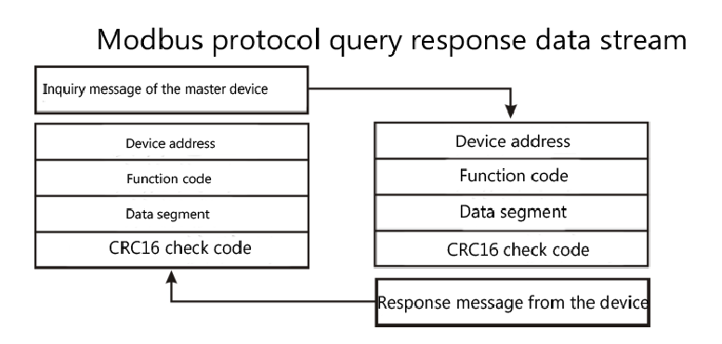
Host query: The query message frame includes device address, function code, data information code, and check code. The address code indicates the slave device to be selected; the function code tells the selected slave device what function to perform, for example, the function code 03 or 04 requires the slave device to read registers and return their contents; the data segment contains the slave device's requirements. Any additional information to perform the function. The check code is used to check the correctness of a frame of information. The slave device provides a method to verify whether the content of the message is correct. It uses the CRC16 calibration rule.
Slave machine response: If the slave device generates a normal response, there are slave address code, function code, data information code and CRC16 check code in the response message. The data information code includes the data collected from the device: like register value or status. If an error occurs, we agree that the slave will not respond.
We stipulate the communication data format used in this instrument: the bit of each byte (1 start bit, 8 data bits, odd parity or even parity or no parity, 1 or 2 stop bits).
The structure of the data frame, that is, the message format:
Device address | Function code | Data segment | CRC16 check code
1 byte | 1 byte | N bytes | 2 bytes (low byte first)

Device address: Consists of one byte, the address of each terminal device must be unique, and only the addressed terminal will respond to the corresponding query.
Function code: tells what function the addressed terminal performs. The following table lists the function codes supported by this series of instruments and their functions。
Function code | Function
03H | Read the value of one or more registers
10H | Write the value of one or more registers
01H | Read the output status of 1 relay
05H | Write output status of 1 relay
Data segment: Contains the data required by the terminal to perform a specific function or the data collected when the terminal responds to a query. The content of these data may be numerical values, reference addresses or setting values。
Check code: CRC16 occupies two bytes and contains a 16-bit binary value. The CRC value is calculated by the transmitting device and then appended to the data frame. The receiving device recalculates the CRC value when receiving the data, and then compares it with the value in the received CRC field. If the two values are not equal, it will happen. Mistake.
The process of generating a CRC16 is：
(1) Preset a 16-bit register as 0FFFFH (all 1s), which is called CRC register.
(2) XOR the 8 bits of the first byte in the data frame with the low byte in the CRC register, and store the result back to the CRC register.
(3) Shift the CRC register one bit to the right, fill the highest bit with 0, and shift out the lowest bit and check.
(4) If the lowest bit is 0: repeat the third step (the next shift); if the lowest bit is 1: XOR the CRC register with a preset fixed value (0A001H).
(5) Repeat the third and fourth steps until 8 shifts. A complete eight bits have been processed in this way。
(6) Repeat steps 2 to 5 to process the next eight bits until all byte processing ends.
(7) The final CRC register value is the value of CRC16.

MODBUS－RTU Example of communication protocol:
4.1、Function code 0x03: read multiple registers
Example: The master wants to read the data of 2 slave registers whose address is 01 and the start address is 0048H
Host send： 01 03 00 48 00 02 CRC
address function code initial address Data length CRC code
Slave response： 01 03 04 12 45 56 68 CRC
address function code Return the number of bytes Register data1 Register data2 CRC code
4.2、Function code 0x10: write multiple registers
Example: The master wants to save 0000,0000 to the slave register at address 000C,000D (the slave address code is 0x01)
Host send：01 10 00 0C 00 02 04 00 00 00 00 F3 FA
address function code initial address Number of write registers Byte count Save data 1 2 CRC code
Slave response：01 10 00 0C 00 02 81 CB
address function code initial address Number of write registers CRC code
4.3、Function code 00x01: read the status of 1 switch output
Example: The master wants to read the output status of phase A relay (the slave address code is 0x01)
Host send：01 01 00 00 00 01 CRC
address function code Start bit Number of read switches CRC code
Slave response：01 01 01 01 CRC
address function code Data length Status data CRC code
4.4、Function code 0x05: write 1 relay
The control command is: "FF00" means the output switch value is "1", that is, the control relay is "closed"; "0000" is the output switch value is "0", that is, the control relay is "off".
Example: The master wants to control the phase A relay to "close" (the slave address is 0x01)
Host send： 01 05 00 00 FF 00 8C 3A
address function code Output bit control command CRC code
Slave response: The content of the message and data sent by the host is exactly the same
4.5、Illustrate
The register in the MODBUS-RTU communication protocol refers to 16 bits (that is, 2 bytes), and the high bit is first.
When setting parameters, be careful not to write illegal data (that is, data values that exceed the data range limit)；
The format of the error code returned by the slave is as follows：
Address code: 1 byte
Function code: 1 byte (the highest bit is 1)
Error code: 1 byte
CRC: 2 bytes
The following error code is returned in response：
81：Illegal function code, that is, the received function code module does not support.
82：Read or write an illegal data address, that is, the data location exceeds the module's readable or writable address range.
83：Illegal data value, that is, the data value that the module receives from the host exceeds the data range of the corresponding address。
4.6、Examples of communication messages
4.6.1 Read data register (function code 03H): read the 3 register values of phase A, the result is: voltage 231.5V, current10.123A, power 2343W, meter address is 1.
Host read data frame：
address | Order | Start address (high order first) | Number of registers (high order first) | Check code (low order first)
01H | 03H | 00H,48H | 00H,03H | 85H,DDH

The meter responds to the data frame：
address | Order | Data length | Data segment (6 bytes) | Check code
01H | 03H | 06H | 5AH,6EH,27H,8BH,09H,27H | F8H,92H

4.6.2 Write data register (function code 10H): set the upper limit of phase A voltage to 260V, the upper limit of phase A current to 50A, and the instrument address to 1.
Host write data frame：
address | Order | initial address | Number of registers | Number of bytes | Data segment | Check code
01H | 10H | 00H,20H | 00H,02H | 04H | 01H,04H,01H,F4H | B1H,9DH

The meter responds to the data frame：
address | Order | initial address | Number of registers | Check code
01H | 10H | 00H,20H | 00H,02H | 40H,02H

五、Precautions
- Pay attention to the auxiliary power information on the product label. The auxiliary power level and polarity of the product cannot be connected wrongly, otherwise the product may be damaged.
- Please refer to the diagram for correct wiring according to the product specifications and models. Be sure to disconnect all signal sources and power before wiring to avoid danger and damage to the equipment. After checking that the wiring is correct, turn on the power to test.
- Voltage circuit or secondary circuit of PT cannot be short-circuited.
- When there is current on the primary side of the CT, it is strictly forbidden to open the secondary circuit of the CT; it is strictly forbidden to connect live wires or unplug the terminals;
- When the product is used in an environment with strong electromagnetic interference, please pay attention to the shielding of the input and output signal lines.
- For centralized installation, the minimum installation interval should not be less than 10mm.
- There is no lightning protection circuit in this series of products. When the input and output feeders of the module are exposed to the harsh outdoor environment, attention should be paid to lightning protection measures.

